***Performance Analysis of FIR Filter Design by using Blackman Window Technique with Butterworth and Chebyshev Low Pass Filters***

By

**Ved Prakash & Rushil Gupta**

**(BTECH/10667/21 & BTECH/10031/21)**

*Report Submitted To*

**Dr. Gauri Shankar Gupta**

**(SP-2023)**



**DEPARTMENT OF ELECTRICAL AND ELECTRONICS**

**ENGINEERING**

**BIRLA INSTITUTE OF TECHNOLOGY**

**MESRA, RANCHI - 835215**

**Abstract**

In many signal-processing applications, digital filters are employed to block undesirable frequencies and amplify the desired output. The Butterworth Low Pass and Chebyshev Type 1 Low Pass Filters, both implemented using the Finite Impulse Response (FIR) filter Blackman windowed approach, are two popular digital filter design techniques that we compare in this research work. These filters' effectiveness is assessed using a number of factors, including stopband attenuation, phase response, and frequency response. It is discovered that the FIR filter Blackman windowed approach works well to lower side lobe levels in the frequency response. Simulations were used to assess these filters' performance, and the results were compared to the ideal filter response.

***Index Term*:** FIR Filter, Blackman Window, Butterworth Low Pass Filter, Chebyshev Type 1 Low Pass Filter, Image Quality Parameters, Noises.

1. **Introduction:**

Digital filters are widely used in signal processing applications to remove unwanted frequencies and enhance the desired signal. The use of digital filters has become increasingly prevalent due to the rapid advancements in digital signal processing techniques. The performance of these filters is evaluated using various parameters such as frequency response, phase response, and stopband attenuation. The objective is to present a comparative study of two popular digital filter design techniques: Butterworth Low Pass and Chebyshev Type 1 Low Pass Filter both implemented using the Finite Impulse Response (FIR) filter Blackman windowed technique. Understanding the performance of digital filters is important for improving signal-processing applications such as audio processing, image processing, and biomedical signal processing. Overall, this study provides a comprehensive analysis of the performance of digital filters implemented using the FIR filter Blackman windowed technique. The results of this study can be used to improve the design of digital filters and enhance the performance of signal processing applications.

**Image noise** refers to random variations in brightness or colour in an image that are not part of the original scene being captured.

1. **Problem Statement:**

Ten noises—Gaussian, Salt & Pepper, Speckle, Rician, Periodic, Poisson, Rayleigh, Gamma, Quantization, and Brownian—will be added to six different images—five coloured and one in grayscale—at various noise intensities (10% to 90%). The noisy image will then have a FIR filter and Butterworth Low Pass and Chebyshev Type 1 Low Pass Filter, applied to it using a Blackman Window, allowing us to calculate several image quality measures including MSE, RMSE, PSNR, SSIM, and IEF to see the effects of the selected filter on image quality.

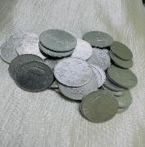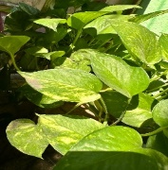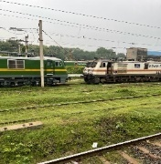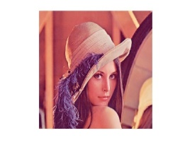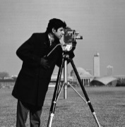The study involved simulating the filters using MATLAB software and analysing the results using various performance metrics.

1. (b) (c) (d) (e) (f)

*Fig. 1. Images Used in this Project:*

*(a) Cameraman.tif (b) Coins.jpg (c) Lena.jpg (d) Tracks.jpg (e) Scenary.jpg (f) Leaf.jpg*

1. **Literature Review:**

After going through some of the papers on the given topics, the following was the summary obtained:

1. “**Performance Analysis of FIR Filter Design by Using Optimal, Blackman Window and Frequency Sampling Methods**”- The writers of this publication (which goes by the name of the study) are employing the spectral responses of the methods outlined above. The resulting Blackman Window graphs demonstrate that the passband is flat, whereas the stopband has ripples and the transition band performs poorly.[1]
2. “**Image Quality Parameter Detection: A Study**”- The researchers discuss all the various Image Quality Parameters, such as PSNR, MSE, etc., in this work.[3]

# “**Design and comparison of Butterworth and Chebyshev type-1 low pass filter using Matlab**”- The essential building blocks (adders, multipliers, etc.) needed to design a filter, as well as the transfer function's poles and zeros, are highlighted in this work. Additionally, it demonstrates how a filter can be created using both software and hardware. The key features are that Butterworth is good for ripple-free and flat responses, whereas Chebyshev delivers more accurate results for the same criteria.[7]

1. "**Image Enhancement Techniques using High pass and Low pass Filters**"-The authors of this piece describe the fundamental methods that can be used to either sharpen or smoothen an image (Low Pass or High Pass filters). The results that the authors obtained using 2D FFT are as follows: The experimental results indicate that high pass and low pass filters are essential filters used in picture editing because they maintain image edges (High Pass) and image details (Low Pass).[4]
2. “**Advantages of Blackman Window over Hamming Window Method for designing FIR Filter**”- The simulation, design, and implementation of the FIR filter using Blackman and Hamming windows are presented in this paper. The advantages of the Blackman window over the Hamming window are additionally illustrated all throughout the paper. The main lobe and side lobe of the magnitude response show the desired outcomes after the simulations using Matlab 7.6 were completed. The filter coefficients are also calculated for the design of the FIR filter.[9]
3. **Methodology:**

This study will use a FIR filter with the Blackman Window Technique, as well as Butterworth Low Pass and Chebyshev Low Pass Filters for image denoising.

1. ***FIR (FINITE IMPULSE RESPONSE) FILTER:***

* **Why FIR (FINITE IMPULSE RESPONSE) FILTER?**

The ability of FIR filters to selectively eliminate noise while keeping picture details and their linear phase response, which guarantees that the filtered image remains true to the original, this makes them a popular choice for image denoising.

* **Why Blackman Window?**

In the Blackman function, there is an extra cosine term. The side lobes are decreased by this additional word Side lobe reduction results in better efficiency and decreased power loss. [2]

* **Data-Driven Design of FIR Filter using Blackman Window**

The basic idea behind using a Blackman filter for image denoising is to convolve the filter with the noisy image to remove high-frequency noise components while preserving the low-frequency details. The filter is designed to have a smooth frequency response, which means that it attenuates high-frequency noise while allowing the low-frequency image details to pass through. The filter coefficients are calculated using a mathematical formula that considers the desired frequency response of the filter.

When simulated, the obtained Blackman Window Coefficients are given below (they were obtained by in-built function of MATLAB):

|  |  |  |
| --- | --- | --- |
| **Coeff.** | **Value** | **Coeff.** |
| h0 | 0 | h50 |
| h1 | 0.001429 | h49 |
| h2 | 0.005813 | h48 |
| h3 | 0.013429 | h47 |
| h4 | 0.024713 | h46 |
| h5 | 0.040213 | h45 |
| h6 | 0.060539 | h44 |
| h7 | 0.086297 | h43 |
| h8 | 0.118024 | h42 |
| h9 | 0.156116 | h41 |
| h10 | 0.20077 | h40 |
| h11 | 0.251927 | h39 |
| h12 | 0.309236 | h38 |
| h13 | 0.372026 | h37 |
| h14 | 0.439309 | h36 |
| h15 | 0.509787 | h35 |
| h16 | 0.581896 | h34 |
| h17 | 0.653851 | h33 |
| h18 | 0.723721 | h32 |
| h19 | 0.789508 | h31 |
| h20 | 0.84923 | h30 |
| h21 | 0.901019 | h29 |
| h22 | 0.943206 | h28 |
| h23 | 0.974396 | h27 |
| h24 | 0.993544 | h26 |
| h25 | 1 | - |

*Table 1. Blackman Window Coefficients.*

* **Flowchart:**

The study was performed by following the given flowchart:

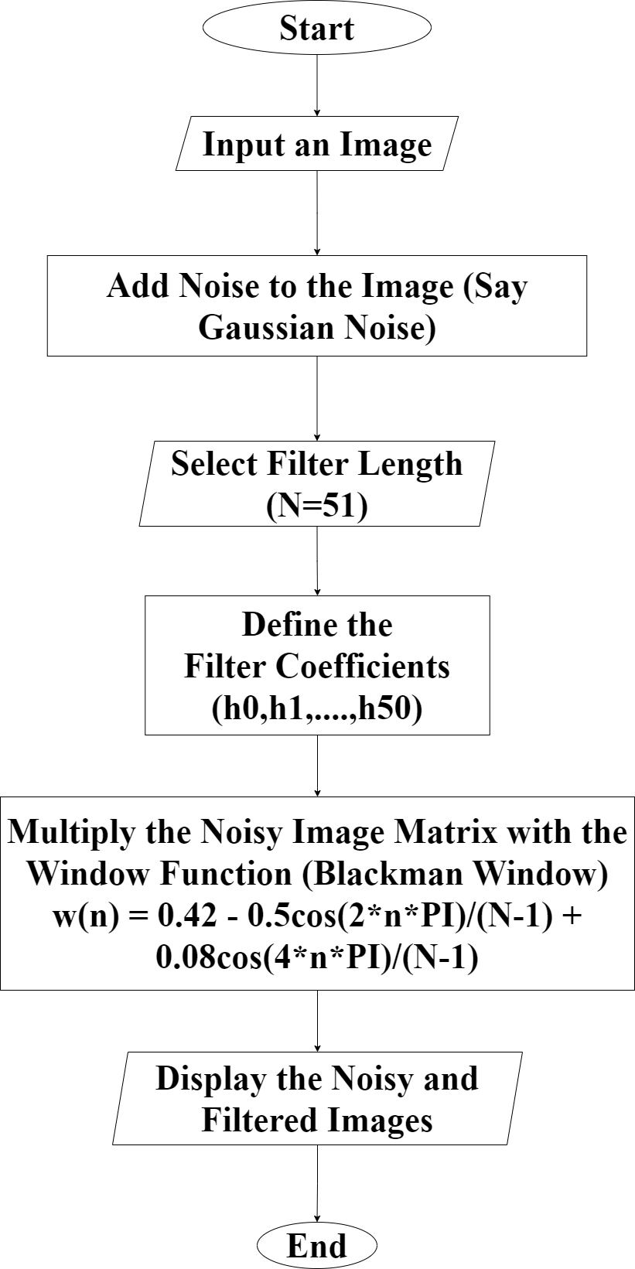

*Flow Chart 1. FIR Filter using Blackman Window.*

The obtained FIR Filter is plotted in Fig. 2.

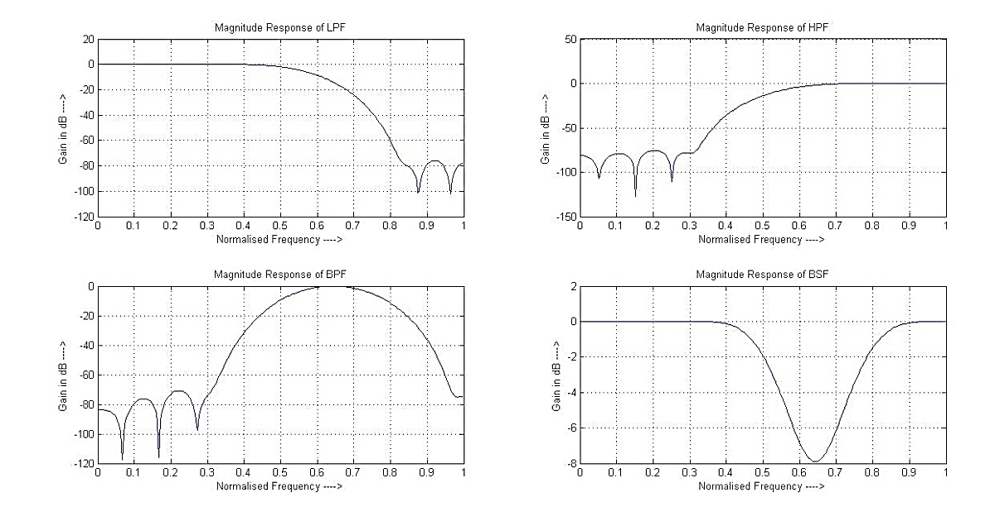

*Fig. 2. Blackman Window Frequency Response.*

1. ***Butterworth Low Pass Filter:***

* **Why Butterworth Low Pass Filter?**

The Butterworth filter's benefits include smooth transitions between the passband and stopband, which provide a better balance between noise reduction and image preservation. In order to meet the demands of the denoising application, the filter's behaviour can also be simply modified by varying the cut-off frequency or filter order.

The Butterworth filter's benefits include smooth transitions between the passband and stopband, which provide a better balance between noise reduction and image preservation. In order to meet the demands of the denoising application, the filter's behaviour can also be simply modified by varying the cutoff frequency or filter order.

* **Data-Driven Design of Butterworth Low Pass Filter**

A **Butterworth Low-Pass Filter** is a type of frequency domain filter used in image processing and signal processing. It is used to remove high-frequency noise from an image by smoothing the image in the frequency domain. In image denoising, the Butterworth low-pass filter is often used to remove high-frequency noise from an image. The filter works by attenuating the high-frequency components of the image while leaving the low-frequency components unaffected.

Where, Ω is the frequency, Ωc is the cut-off frequency and N is the order of Filter.

* **Flowchart:**

Butterworth Low Pass Filter was designed by following this flowchart:

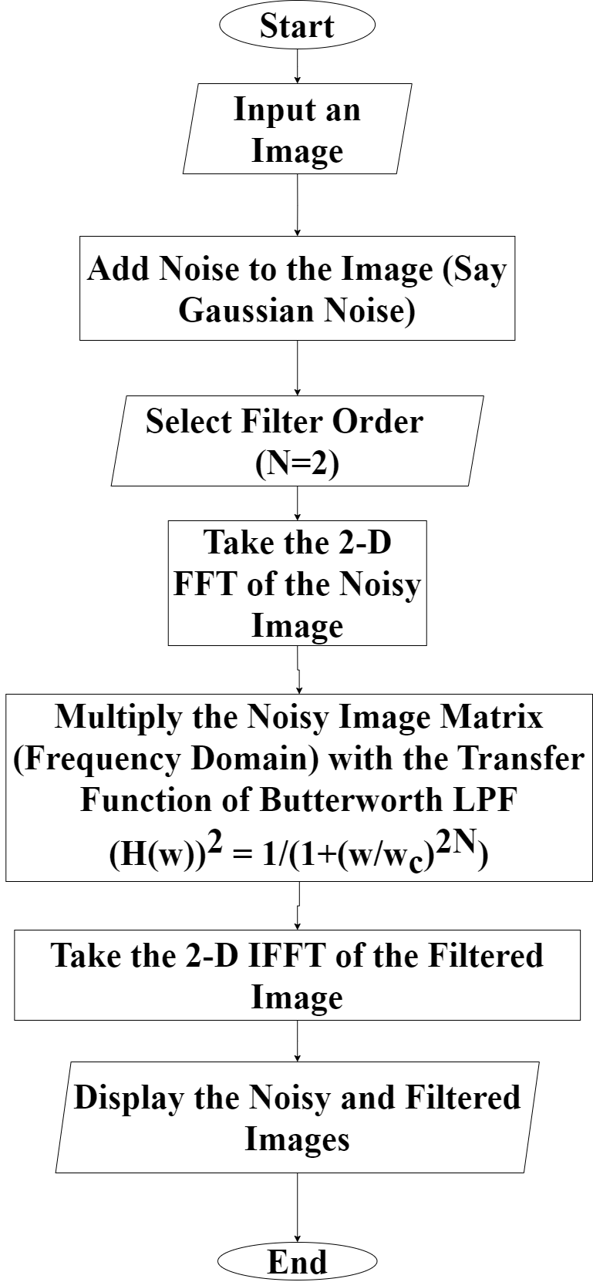

*Flow Chart 2. Butterworth Low Pass Filter.*

The obtained Butterworth low pass Filter is plotted in Fig. 3.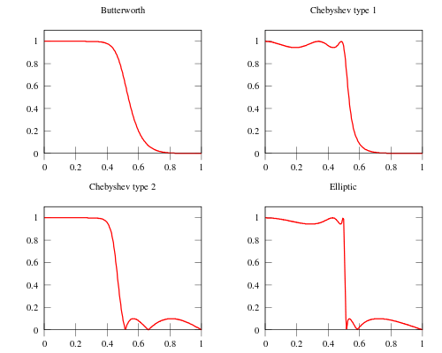

Attenuation

Normalized Frequency

*Fig. 3. Butterworth Low Pass Normalised Responses.*

1. ***Chebyshev Type 1 Low Pass Filter:***

* **Why Chebyshev Type 1 Low Pass Filter?**

Chebyshev Type 1 low pass filters are an excellent option for applications requiring picture denoising because of its steep roll-off, well defined passband and stopband, and capacity for including ripple in the passband.

* **Data-Driven Design of Chebyshev Type 1 Low Pass Filter**

**Chebyshev Low Pass Filter** is a type of filter that can be used in image denoising techniques. In image processing, noise reduction is an important task to improve the quality of an image. It can be used to remove high-frequency noise from an image.

The Chebyshev low pass filter has a ripple in the passband. It can be designed to have a steeper cut-off than other types of filters, such as Butterworth filters. It can be designed to have a maximum ripple in the passband and a minimum attenuation in the stopband.

The obtained graph of Chebyshev Type 1 Low Pass Filter is plotted below:

Attenuation

Normalized Frequency

*Fig. 4. Chebyshev Type 1 Low Pass Normalised Responses.*

* **Flowchart:**

Chebyshev Filter was developed using this flowchart:

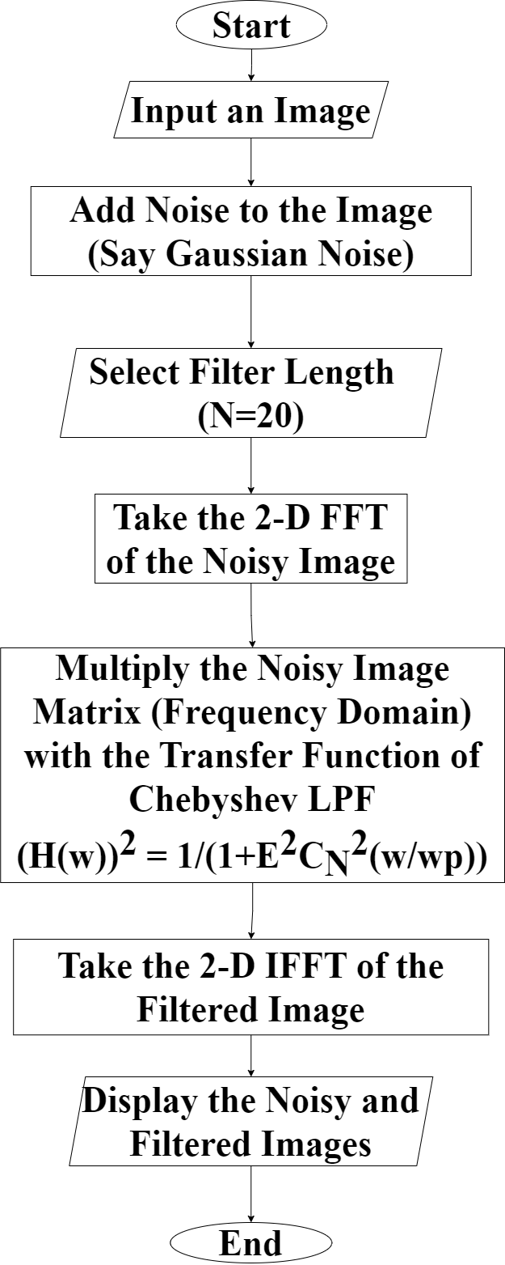

*Flow Chart 3. Chebyshev Low Pass Filter.*

* ***Internal* Parameters:**

We have taken the following values for internal parameters since we are getting the best results during our simulation[1][7]:

|  |  |  |  |  |  |  |  |
| --- | --- | --- | --- | --- | --- | --- | --- |
| **FIR Filter using Blackman Window** | | **Butterworth Low Pass Filter** | | **Chebyshev Low Pass Filter** | | | |
| **Filter Length** | **Cut-off Freq** | **Filter Order** | **Cut-off Freq** | **Filter Length** | **Cut-off Freq** | **Passband Ripple** | **Stopband Attenuation** |
| 51 | 1 rad/sec | 2 | 0.6 rad/sec | 20 | 0.6 rad/sec | 1dB | 40dB |

*Table 2. Internal Parameters.*

1. **Results:**

The FIR Filter employing Blackman technique with Butterworth and Chebyshev Type 1 Low Pass Filters have become a well-liked denoising algorithm in the research community due to its excellent performance in reducing noise in photos.

They can successfully reduce noise when compared to the conventional denoising approach, and the resulting image is cleaner and more detailed. The method outperforms state-of-the-art denoising algorithms in terms of peak signal-to-noise ratio (PSNR) when tested on a variety of noisy pictures, including statistical noise, Gaussian noise, etc.

The Experimental Values of PSNR show an increase of the following Values with respect to Noisy Image:

|  |  |  |  |  |
| --- | --- | --- | --- | --- |
| **Noise** | **Noise Level** | **Blackman Window** | **Butterworth Filter** | **Chebyshev Filter** |
| |  | | --- | | **GAUSSIAN NOISE** | |  | |  | |  | |  | |  | |  | |  | |  | | 10% | 3.734702 | 5.52806 | 0.512938 |
| 20% | 5.070708 | 6.950455 | 2.35691 |
| 30% | 5.539488 | 7.405045 | 3.158857 |
| 40% | 5.803327 | 7.636269 | 3.633402 |
| 50% | 5.907133 | 7.726875 | 3.914333 |
| 60% | 5.989166 | 7.779825 | 4.116902 |
| 70% | 6.044924 | 7.807349 | 4.281678 |
| 80% | 6.069836 | 7.817773 | 4.395148 |
| 90% | 6.121389 | 7.841885 | 4.496353 |
| |  | | --- | | **IMPULSE NOISE** | |  | |  | |  | |  | |  | |  | |  | |  | | 10% | 0.216886 | 1.667578 | -3.41196 |
| 20% | 2.879748 | 4.453391 | -0.36143 |
| 30% | 4.23652 | 5.87694 | 1.395461 |
| 40% | 5.026559 | 6.698614 | 2.591303 |
| 50% | 5.530889 | 7.189603 | 3.477297 |
| 60% | 5.822389 | 7.436526 | 4.130467 |
| 70% | 5.986974 | 7.554631 | 4.619643 |
| 80% | 6.088185 | 7.596839 | 5.001689 |
| 90% | 6.119111 | 7.559273 | 5.28189 |
| |  | | --- | | **PERIODIC NOISE** | |  | |  | |  | |  | |  | |  | |  | |  | | 10% | -0.00247 | -0.00236 | -0.007 |
| 20% | -0.00248 | -0.00238 | -0.00702 |
| 30% | -0.00248 | -0.00237 | -0.00702 |
| 40% | -0.00248 | -0.00237 | -0.00702 |
| 50% | -0.00267 | -0.00252 | -0.00721 |
| 60% | -0.00247 | -0.00237 | -0.00701 |
| 70% | -0.00248 | -0.00239 | -0.00702 |
| 80% | -0.00247 | -0.00237 | -0.00701 |
| 90% | -0.00249 | -0.00237 | -0.00702 |
| |  | | --- | | **POISSON NOISE** | |  | |  | |  | |  | |  | |  | |  | |  | | 10% | -0.00201 | -0.00183 | -0.00652 |
| 20% | -0.00189 | -0.00172 | -0.0064 |
| 30% | -0.00173 | -0.00154 | -0.00621 |
| 40% | -0.00148 | -0.00129 | -0.00598 |
| 50% | -0.00115 | -0.00098 | -0.00563 |
| 60% | -0.00067 | -0.00048 | -0.00512 |
| 70% | 0.000113 | 0.000345 | -0.00433 |
| 80% | 0.001331 | 0.001625 | -0.00303 |
| 90% | 0.003205 | 0.003715 | -0.00087 |
| |  | | --- | | **SPECKLE NOISE** | |  | |  | |  | |  | |  | |  | |  | |  | | 10% | 1.034516 | 2.642773 | -2.56449 |
| 20% | 3.126622 | 4.848799 | -0.07271 |
| 30% | 4.142115 | 5.909127 | 1.33312 |
| 40% | 4.709289 | 6.479219 | 2.219922 |
| 50% | 5.006976 | 6.761625 | 2.749749 |
| 60% | 5.181398 | 6.911739 | 3.082846 |
| 70% | 5.308943 | 7.021268 | 3.33265 |
| 80% | 5.383699 | 7.095434 | 3.506726 |
| 90% | 5.460167 | 7.157895 | 3.658766 |
| |  | | --- | | **GAMMA NOISE** | |  | |  | |  | |  | |  | |  | |  | |  | | 10% | -0.00278 | -0.0027 | -0.00696 |
| 20% | -0.00281 | -0.00231 | -0.00662 |
| 30% | -0.00471 | -0.00394 | -0.00818 |
| 40% | -0.00782 | -0.00732 | -0.0112 |
| 50% | -0.01074 | -0.01168 | -0.01459 |
| 60% | -0.01169 | -0.01631 | -0.01609 |
| 70% | -0.01038 | -0.02104 | -0.01457 |
| 80% | -0.00785 | -0.01927 | -0.01121 |
| 90% | -0.00547 | 0.001831 | -0.00815 |
| |  | | --- | | **RAYLEIGH NOISE** | |  | |  | |  | |  | |  | |  | |  | |  | | 10% | -0.00229 | -0.00214 | -0.00682 |
| 20% | 0.000336 | 0.000628 | -0.00413 |
| 30% | 0.003179 | 0.003753 | -0.00108 |
| 40% | 0.004567 | 0.005916 | 0.000806 |
| 50% | 0.004645 | 0.006892 | 0.001431 |
| 60% | 0.004125 | 0.007227 | 0.001369 |
| 70% | 0.003541 | 0.007203 | 0.001051 |
| 80% | 0.00306 | 0.006914 | 0.000675 |
| 90% | 0.002571 | 0.006475 | 0.000283 |
| |  | | --- | | **BROWNIAN NOISE** | |  | |  | |  | |  | |  | |  | |  | |  | | 10% | -6.79666 | -5.6599 | -10.4505 |
| 20% | -1.32702 | -0.70168 | -3.63284 |
| 30% | -1.65917 | -1.04142 | -4.11204 |
| 40% | -2.52241 | -1.71332 | -5.42474 |
| 50% | -2.21331 | -1.47009 | -4.9347 |
| 60% | -0.66823 | -0.18329 | -2.53957 |
| 70% | -0.27643 | 0.128475 | -1.8659 |
| 80% | -0.13098 | 0.264978 | -1.53844 |
| 90% | -1.63369 | -0.96458 | -4.0217 |
| |  | | --- | | **RICIAN NOISE** | |  | |  | |  | |  | |  | |  | |  | |  | | 10% | 0.001784 | 0.002053 | -0.00244 |
| 20% | 0.001808 | 0.002027 | -0.0024 |
| 30% | 0.001814 | 0.002039 | -0.00238 |
| 40% | 0.001805 | 0.002032 | -0.00239 |
| 50% | 0.001802 | 0.002043 | -0.00242 |
| 60% | 0.001822 | 0.002091 | -0.00238 |
| 70% | 0.001819 | 0.002035 | -0.00239 |
| 80% | 0.001795 | 0.002012 | -0.00242 |
| 90% | 0.001827 | 0.00206 | -0.00238 |

*Table 3. Increase in PSNR Values of Filtered Image with respect to Noisy Image.*

The following shows a sample of the different filter on an image added with a noise.

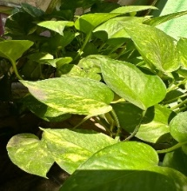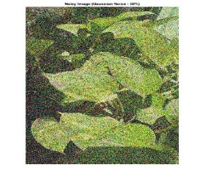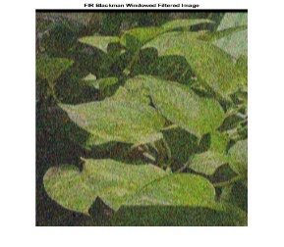

1. (b) (c) 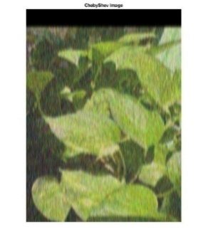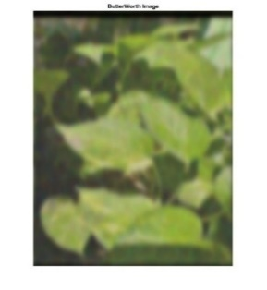

(d) (e)

*Fig. 5. Sample Outputs.*

*(a) Original Image. (b) Noisy Image (Gaussian Noise 30%). (c) FIR Filtered Image. (d) Butterworth Filtered Image. (e) Chebyshev Filtered Image.*

**PSNR Values Graphs for all Images and all Noises:**

The Following shows the PSNR Values for all noises applied to Coins.jpg Image:

(a)

(b)

(c)

(d)

(e)

(f)

(g)

(h)

*Fig. 6. PSNR Values for all Noise Level for Coins.jpg*

The Following shows the PSNR Values for all noises applied to Leaf.jpg Image:

(a)

(b)

(c)

(d)

(e)

(f)

(g)

(h)

*Fig. 7. PSNR Values for all Noise Level for leaf.jpg*

The Following shows the PSNR Values for all noises applied to Scenery.jpg Image:

(a)

(b)

(c)

(d)

(e)

(f)

(g)

(h)

*Fig. 8. PSNR Values for all Noise Level for Scenery.jpg*

The Following shows the PSNR Values for all noises applied to Tracks.jpg Image:

(a)

(b)

(c)

(d)

(e)

(f)

(g)

(h)

*Fig. 9. PSNR Values for all Noise Level for Track.jpg*

The Following shows the PSNR Values for all noises applied to Cameraman.tif Image:

(a)

(b)

(c)

(d)

(e)

(f)

(g)

(h)

*Fig. 10. PSNR Values for all Noise Level for Cameraman.tif*

The Following shows the PSNR Values for all noises applied to Lena.png Image:

(a)

(b)

(c)

(d)

(e)

(f)

(g)

(h)

*Fig. 11. PSNR Values for all Noise Level for Lena.png*

1. **Conclusion:**

In conclusion, the image denoising process using FIR filter Blackman window with Butterworth and Chebyshev Type 1 low pass filters is an effective method for reducing noise in images. Both low pass filters provide a sharp cut-off frequency and a steep roll-off, making them ideal for removing high-frequency noise.

The Blackman window function is used to design the FIR filter, which provides a smooth transition from the passband to the stopband, resulting in a high-quality filtered image. The Butterworth and Chebyshev Type 1 filters are used to design the frequency response of the FIR filter, which determines the cut-off frequency and the amount of attenuation in the stopband.

As per Fig.7 to 11, after **50%** noise level, the output image quality starts to degrade.

Out of all the noises discussed above, **Gaussian Noise** gives the best result, in all the three chosen filters, as shown in Fig.7 to 11 and for almost all other images, the graph shows decrease in PSNR values with respect to noisy image.

According to the graphs in Fig. 7 to 11, the chosen filters generally function best for Gaussian Noise (the PSNR value improves), while for the other types of noise, the filters either fail to denoise the noisy image or they deteriorate it (the PSNR value drops).

**Computation Time:** 20 sec per image per noise.

1. **References:**
2. Shamsul Alam, S. M. & Tariq Hasan, Md. (2010). “Performance Analysis of FIR Filter Design by Using Optimal, Blackman Window and Frequency Sampling Methods”. International Journal of Electrical & Computer Sciences IJECS-IJENS Vol:10 No:01
3. Sulaiman, I. A. & Hassan, H. Md. (2020). “Design, comparison and analysis of low pass FIR filter using window techniques method”. Elsevier. Doi: https://doi.org/10.1016/j.matpr.2020.10.952
4. Gogoi, M. & Ahmed, M. (2016). “Image Quality Parameter Detection: A Study”. International Journal of Computer Sciences and Engineering. Vol-4 Special Issue-7.
5. Halalli, B. & Makandar, A. (2015). “Image Enhancement Techniques using Highpass and Lowpass Filters”. International Journal of Computer Applications. Volume 109 – No. 14
6. Prajoy, P. & Hasan, Md. Mehedi & Islam, Md. R., Sayeed, M. (2020). “Design and Implementation of Butterworth, Chebyshev-I and Elliptic Filter for Speech Signal Analysis”. International Journal of Computer Applications. Doi: <https://doi.org/10.5120/17195-7390>
7. Ahmed, Suhaib & Bashir, Mudasir & Suri, Ashish (2014). “Low Pass FIR Filter Design and Analysis Using Hamming, Blackman and Kaiser Windows”. International Journal of Advanced Research in Electrical, Electronics and Instrumentation Engineering. Volume: 3, Issue: 4.
8. Malica, Tushar & Shekhar, Singdha & Ali, Zakir (2011). “Design and Comparison of Butterworth and Chebyshev type-1 low pass filter using MATLAB”. International Journal of Engineering Sciences ISSN: 2229-6913 Issue Sept 2011, Vol. 4
9. Anju & Katiyar Mamta (2012). “Design of Butterworth and Chebyshev1 Lowpass Filter for Equalized Group Delay”. International Journal of Advanced Research in Computer Science and Software Engineering. Vol. 2 Issue 5
10. Chakraborty, Subhadeep (2013). “Advantages of Blackman Window over Hamming Window Method for designing FIR Filter”. International Journal of Computer Sciences and Engineering. Vol-4 Special Issue-7.